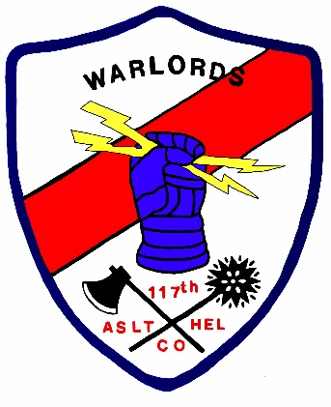

REGISTRATION FORM
REGISTRATION & PAYMENT CUTOFF RECEIVED BY 9/15/2024

NAME: _____________________________________________________________________
NAME (S) of ADDITIONAL ATTENDEES:________________________________________
ADDRESS:__________________________________________________________________
CITY:________________________________STATE:_____________ZIP:________________
EMAIL:____________________________________________________
PHONE:___________________________________________________
NUMBER OF ATTENDEES:___________________
ARRIVAL DATE:_________________________________
REUNION COST: (Includes all meaks except Early Bird)…………….$85.00/person
EARLY BIRD DINNER:…………………………………………………………..$23.00/person
TOTAL ENCLOSED……………………………………………………….___________________
MAIL CHECK TO: 170 JACKSON ROAD, NEW CASTLE, KY 40014-6731

